--Creating a table called restaurant_orders
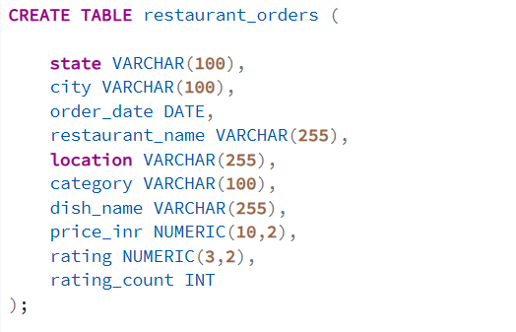

-- Too seee the table

-- now inserting/importing data into that table
--we can use query but we have used the ui fn
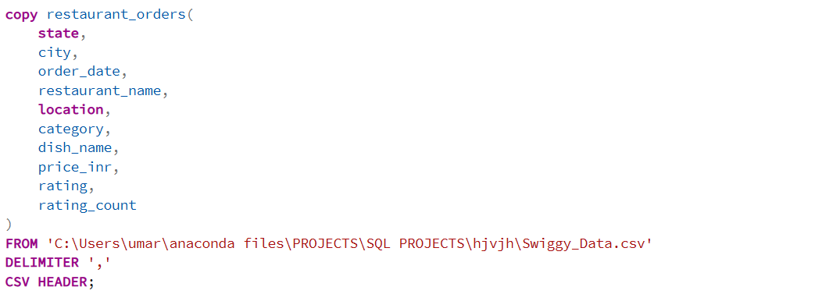

--Data Validation & Cleaning
--1.null checks
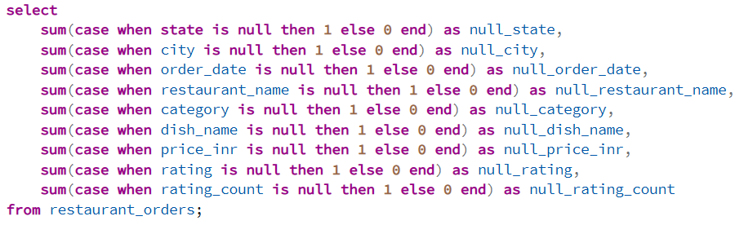

--2.Blank or Empty string(used for dimentions)
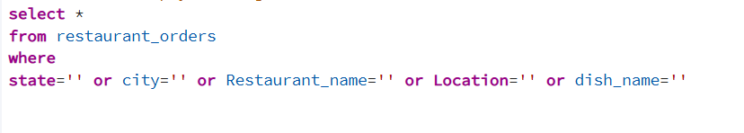

--3.Duplicate check
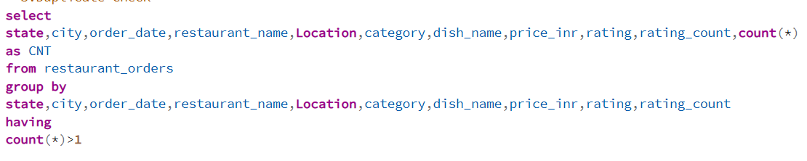

-- deleting the duplicate that we foundd

---Creating Schema(dimention table)
--1.Date Table
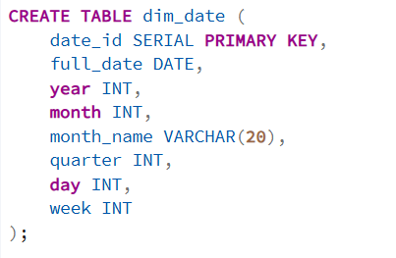
select * from dim_date
--2. Loc Table
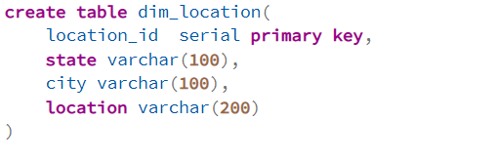
select * from dim_location
--3. Restaurant Table
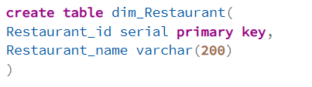
select * from dim_Restaurant
--4. Category Table
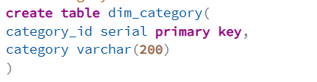
select * from dim_Category

--5. Dish Table
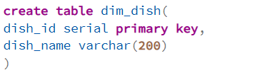
select * from dim_dish

---Creating Schema(Fact table)
Fact Restaurant Table
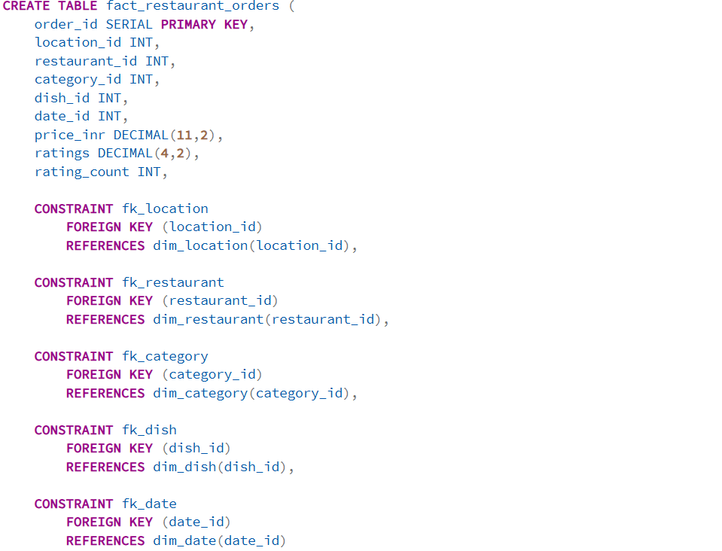
select * from fact_restaurant_orders

--- inserting data into tables that we made
--dim_date
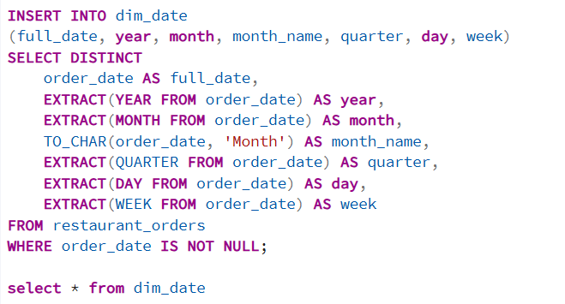
--dim_location
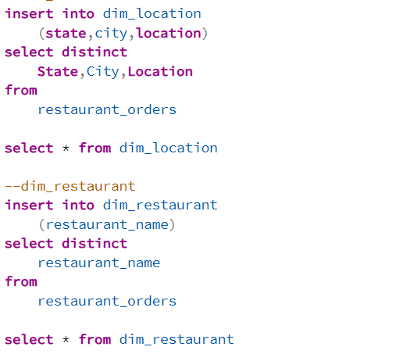
--dim_restaurant
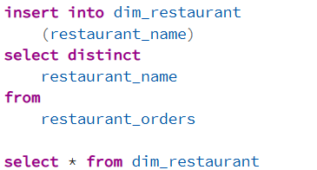

--dim category
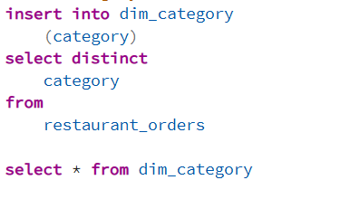
--dim_dish
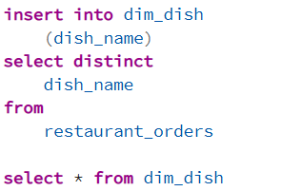
--fact_restaurant_orders
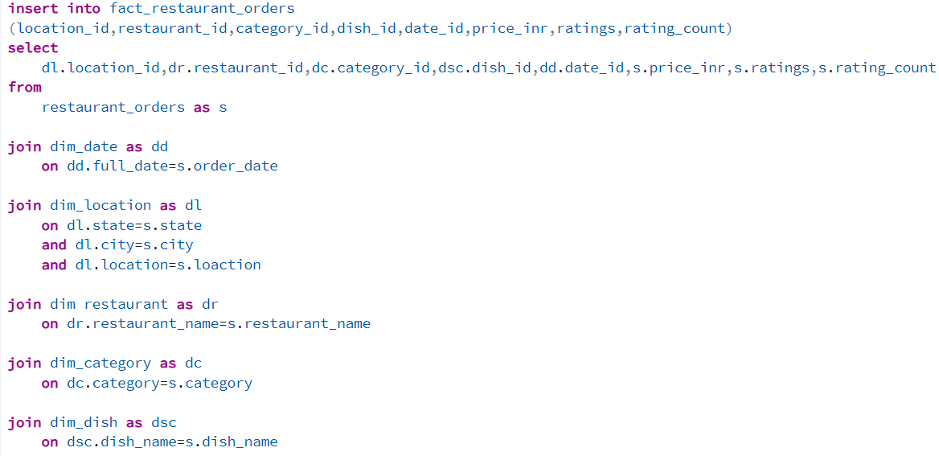
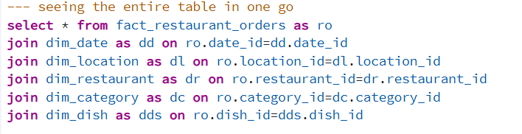
/Output
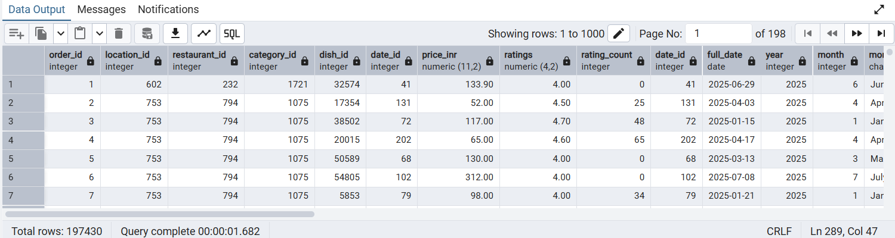
----Till here we are done with our preprocessing stage now we will state our analysis based on the requirements docs----

---KPIs
--Total Orders
/Output
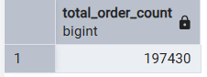
/Insight
197430 no. of total orders we have go

--Total Revenue
SELECT
/Output
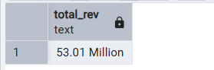
/Insight
53.01 is the total rev that we have generated

--Avg Price
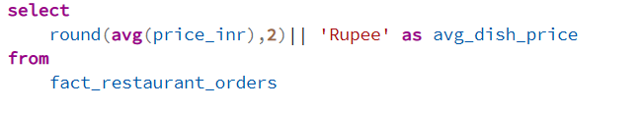
/Output
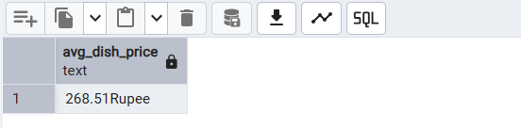
/Insight
The avg price of items is 268.51 Rupee

--Avg Ratings
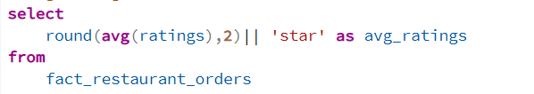
/Output
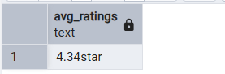
/Insight
4.34 star is the avg ratings that the customers are giving

---Deep Dive Bussiness Analysis
--Date Based Analysis
-- Monthly orders Trends
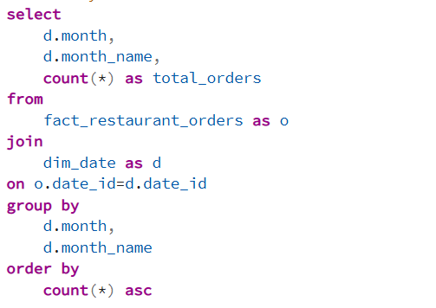

/Output
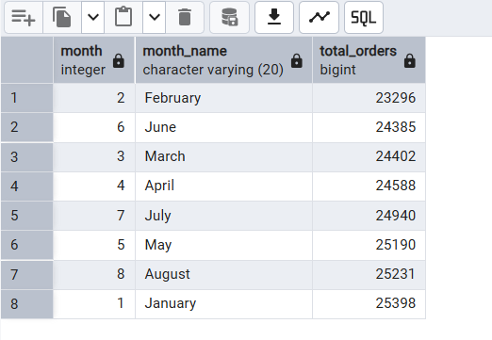
-- Monthly Rev Trends
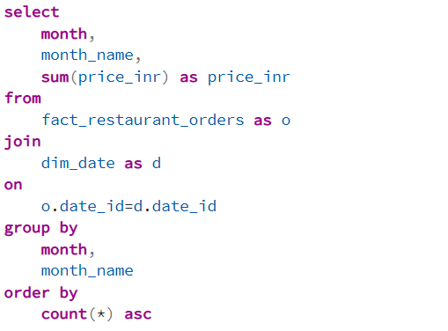

/Output
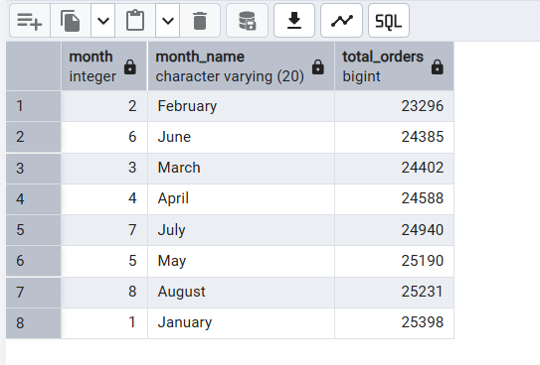
--Quarterly Trend
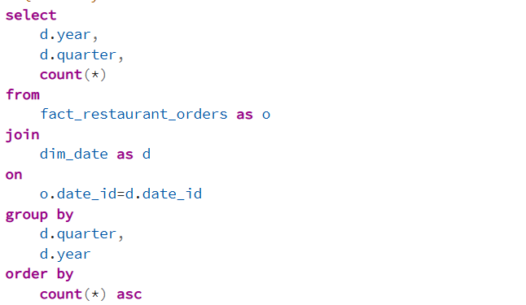
/Output
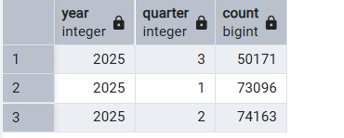
--Yearly Trend
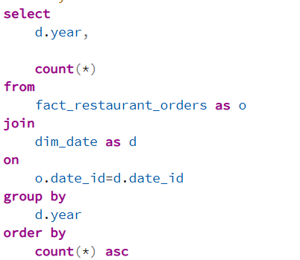
/Output
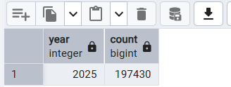

-- Order BY day of week
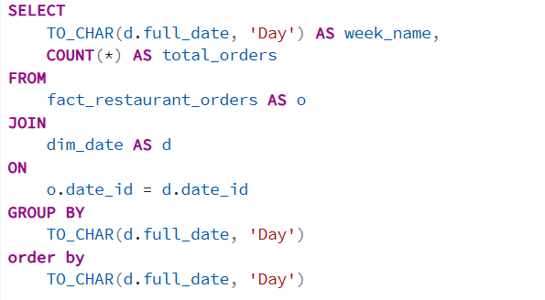
---Location Based Analysis
--Top 10 cities by order volume
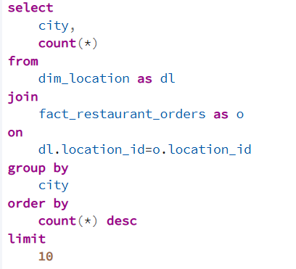
/Output
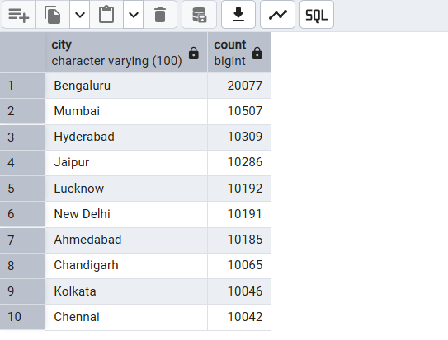
--Rev contribution by state
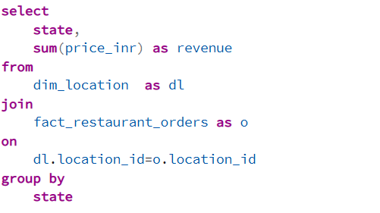
/Output
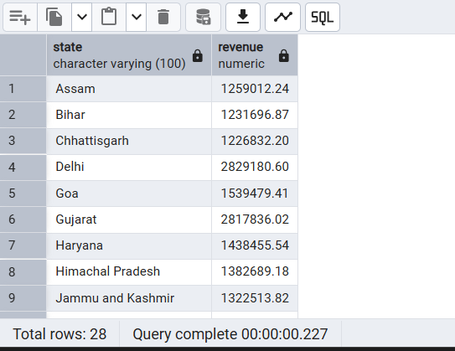

---Food Performance
--Top 10 restaurant by orders
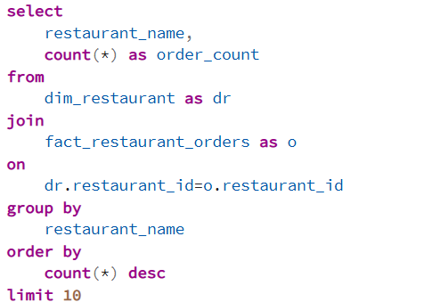
/Output
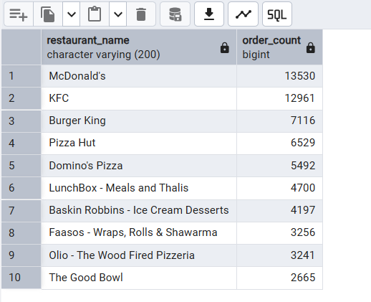
--Top categories
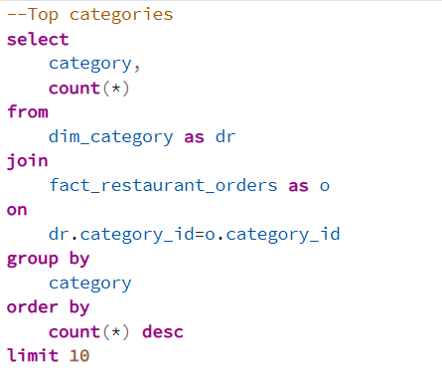
/Output
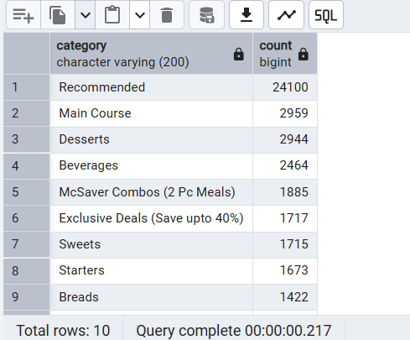

--Most ordered dishes
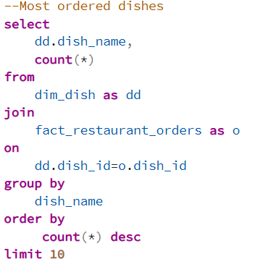
/Output
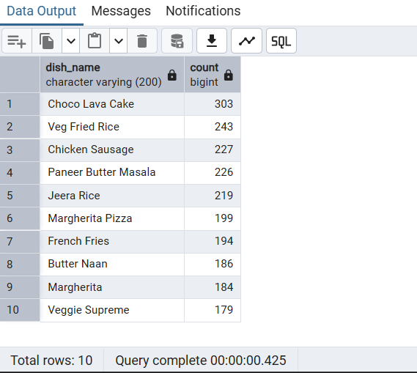
--Cuisine performace (orders + avg ratings)
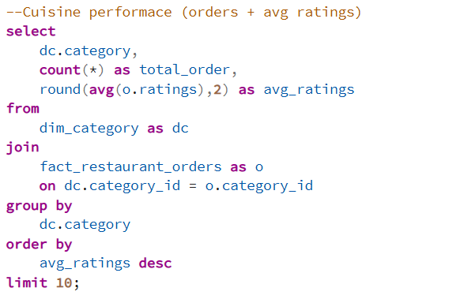 -
/Output
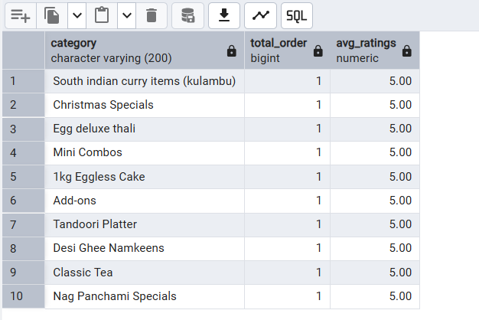

-Total orders by price range
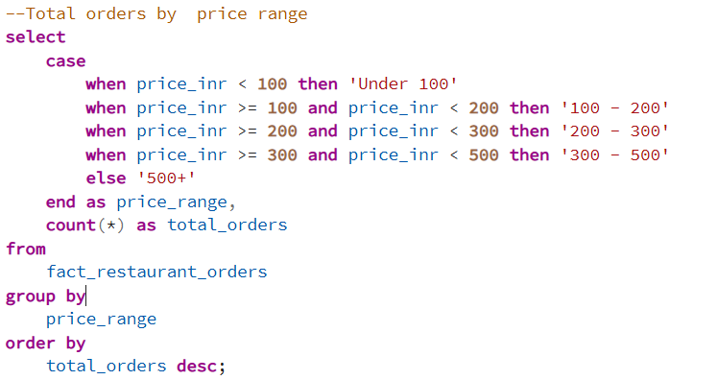
/Output
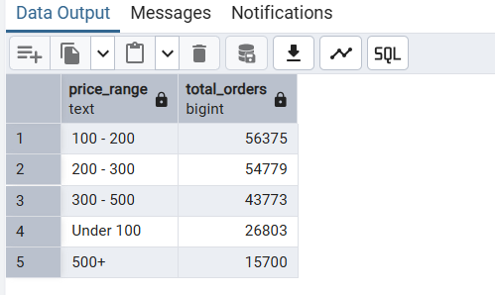

--Ratings count distribution
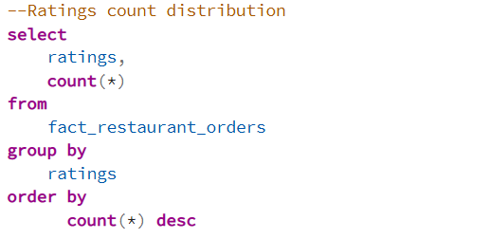
/Output

